CALCULATING FAMILY EXPENSES USING SERVICE NOW

TEAM ID: LTVIP2026TMIDS24859
Team Leader: Balagam Renuka Lakshmi Devi
Team Member: A Manaswini
Team Member: A Veda Varshini
Team Member: A Pravallika

Seshadri Rao Gudlavalleru Engineering College

INDEX
- Introduction
- Abstract
- Problem statement
- Solution
- Practical use
- Knowledge gained
- Milestone 1: Setting up service now instance
- Milestone 2: Creation of new update set
- Milestone 3: Creation of table family expenses 10.Milestone 4: Creation of table daily expenses 11.Milestone 5: Creation of relationship
- Milestone 6: Configuring Related list on family expenses
- Milestone 7: Creation of Business rules 14.Milestone 8: Configure the relationship 15.Conclusion

INTRODUCTION
Managing family expenses is one of the most important aspects of financial planning, yet it is often overlooked or handled in unstructured ways like handwritten notes or spreadsheets. Families frequently face challenges such as overspending, lack of budget control, and difficulty in analyzing where their money goes. To address these issues, technology can play a vital role by providing structured, automated, and user-friendly solutions.
This project, “Calculating Family Expenses Using ServiceNow,” aims to create a digital system that helps track, categorize, and manage family expenses efficiently.
ServiceNow, known for its robust workflow automation and application development capabilities, provides an excellent platform for building such a system. By leveraging ServiceNow, this project transforms expense management into a more streamlined process with features like expense categorization, daily tracking, budget limits, reporting, and automated business rules.
The system will not only simplify financial management for families but also provide real-time insights into spending patterns, allowing better decision-making. With its scalability and flexibility, the solution can be expanded to suit different family structures and even adapted for small business expense management. Ultimately, the project showcases how a powerful enterprise platform like ServiceNow can be applied beyond IT workflows to solve everyday problems in an innovative and practical way.

ABSTRACT

Expense management plays a crucial role in maintaining financial stability within families, yet traditional methods such as manual tracking or spreadsheets often lead to errors, lack of visibility, and poor decision-making. To address this challenge, this project focuses on designing and implementing a Family Expense Management System using ServiceNow.
The application leverages ServiceNow’s powerful low-code development environment to create structured tables, relationships, and automated workflows for recording and analyzing expenses. Key features include categorizing expenses (such as food, utilities, and transport), maintaining family member details, linking daily transactions, and applying business rules to validate data and automate calculations. By configuring related lists and creating meaningful reports, the system provides users with a clear overview of their financial habits and budget limits.
The proposed solution not only simplifies day-to-day expense tracking but also provides real-time insights into spending patterns, enabling families to make smarter financial decisions. Furthermore, the project demonstrates the versatility of ServiceNow beyond traditional IT service management, showcasing its potential in solving practical, real-world problems.

PROBLEM STATEMENT

Managing household expenses is often a difficult and time- consuming task for families. Most families rely on manual methods such as notebooks, receipts, or spreadsheets to track their daily spending. These methods come with several challenges:
- Lack of real-time tracking of expenses.
- Difficulty in categorizing and consolidating expenses like food, utilities, rent, and transportation.
- Limited ability to analyze spending patterns or generate reports.
- High chances of errors due to manual data entry.
- No automation to alert families about overspending or exceeding budgets.
As a result, families often lose visibility into their financial flow, making it harder to control budgets or make informed financial decisions. This creates the need for a systematic, automated, and user-friendly solution to manage and calculate family expenses efficiently.

SOLUTION
The proposed solution is to build a Family Expense Management System on the ServiceNow platform. ServiceNow, being a robust low- code/no-code platform, provides all the tools required to create structured applications without needing extensive programming knowledge.
The solution involves:
- Creating custom tables to store family member details and daily expenses.
- Defining relationships between family members and their respective expenses for easy tracking.
- Configuring related lists so that expenses linked to each family member can be viewed in one place.
- Implementing business rules to automate calculations, validate entries, and ensure data accuracy.
- Generating reports and dashboards to visualize monthly/annual spending and highlight budget deviations.
- Using update sets to track and migrate customizations, ensuring proper version control.

PRACTICAL USE

The Family Expense Management System built on ServiceNow helps families track, categorize, and analyze their expenses in a structured way. It simplifies budgeting, reduces errors from manual tracking, and provides real-time insights into spending patterns. Families can use it to set limits, monitor monthly expenses, and generate reports for better financial decisions. Beyond households, the same system can be adapted for small businesses to manage cash flow and daily transactions effectively, proving the versatility of ServiceNow in solving practical, non-IT problems

KNOWLEDGE GAINED

- Learned how to set up and configure a ServiceNow developer instance for building applications.
- Understood the importance of update sets for tracking and migrating customizations.
- Gained practical skills in creating custom tables and defining fields to store structured data.
- Learned how to establish relationships between tables for linked data management.
- Practiced configuring related lists for easier navigation and record visibility.
- Understood how to create and apply business rules for automation and validations.
- Gained insights into data modeling and database concepts within ServiceNow.
- Learned how to generate reports and dashboards for real-time analysis.
- Understood how ServiceNow can be applied to non-IT use cases like family expense tracking.
- Improved overall knowledge of workflow automation and low- code development.

MILESTONE 1: SETTING UP THE SERVICE NOW INSTANCE
- Go to the official ServiceNow Developer portal: https://developer.servicenow.com and create a developer account.
- After signing in, open the Personal Developer Instance section from the dashboard.
- Select Request Instance to generate a fresh ServiceNow environment for development.
- Provide the necessary details (like version selection) and confirm your request.
- Wait for the confirmation email containing your instance URL and login credentials.
- Use the credentials to log in to your newly created ServiceNow instance.
- Once inside, explore the interface and begin working on the platform.
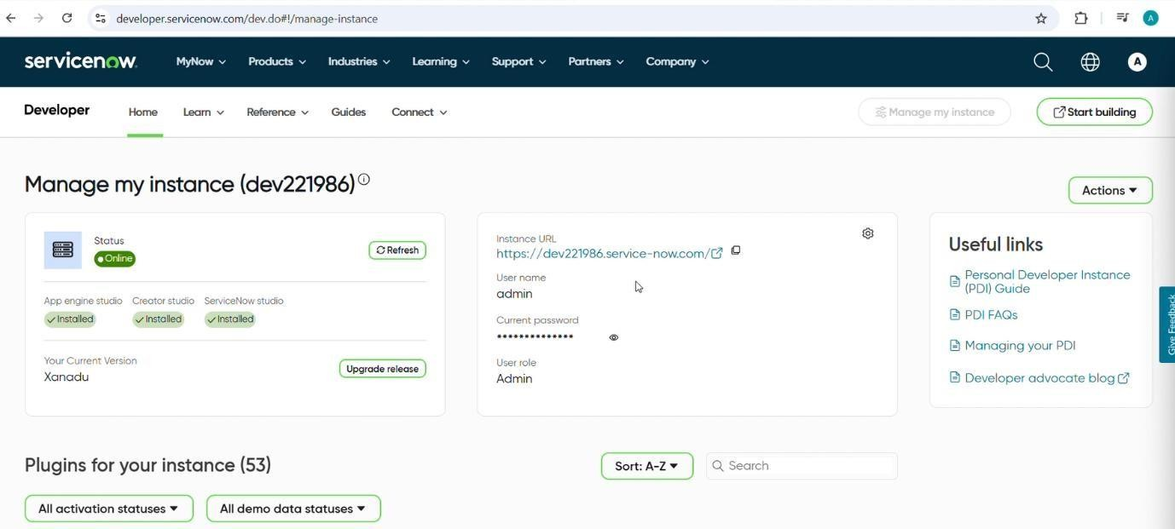

MILSTONE 2: CREATION OF NEW UPDATE SET
- Log in to your ServiceNow instance and go to the Application Navigator.
- Search for Update Sets and open Local Update Sets under System Update Sets.
- Click on New to create a fresh update set.
- Enter the following details:
  - Name: Family Expenses
  - Description: Update set to capture all configurations related to the Family Expense Management project.
- Save the record and mark it as the Current Update Set, so every change you make is tracked under this set.
- Verify that the update set is active by checking the header at the top of the screen.
- From this point forward, all customizations (tables, relationships, and business rules) will be recorded inside the Family Expenses update set.
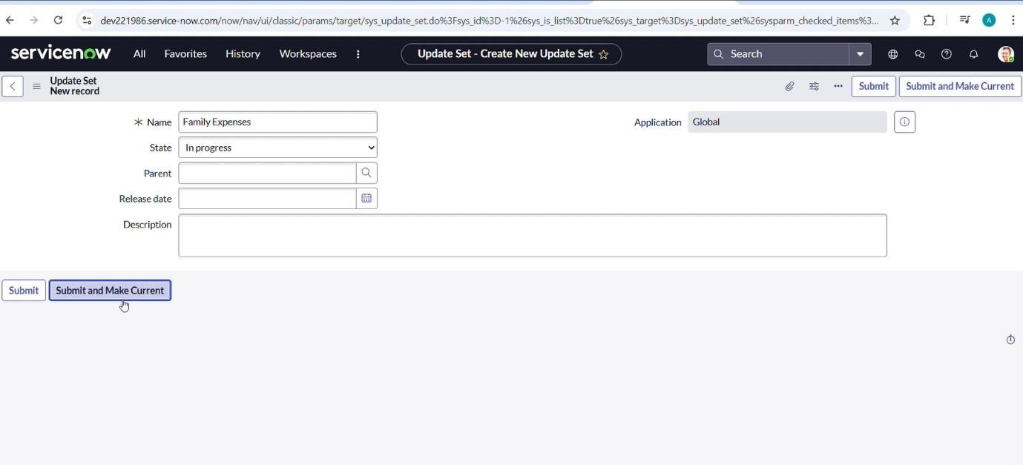

MILSTONE 3: CREATION OF TABLE FAMILY EXPENSES
Activity 1 – Creating the Family Expenses Table
- In your ServiceNow instance, navigate to All > Tables using the filter navigator.
- Click on New to create a new table.
- Fill in the required details:
  - Label: Family Expenses
  - Name: (This will be auto-generated based on the label)
  - New Menu Name: Family Expenditure
- Save the record to create the new table.

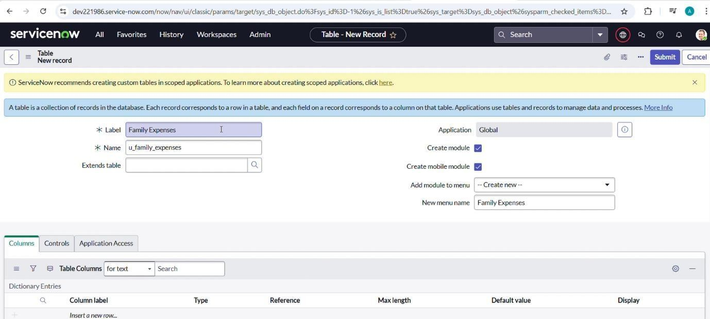

MILSTONE 3: CREATION OF TABLE FAMILY EXPENSES

Activity 2 – Adding Columns to the Family Expenses Table
Duration: 1 Hour
Skill Tags: Table Configuration, Data Modeling, ServiceNow Basics
- Open the newly created Family Expenses table.
- To add columns, double-click near the existing columns to insert a new row.
- Enter the following details one by one:
- Column Label: Number
  - Type: String
- Column Label: Date
  - Type: Date
- Column Label: Amount
  - Type: Integer
- Column Label: Expense Details
  - Type: String
  - Max Length: 800
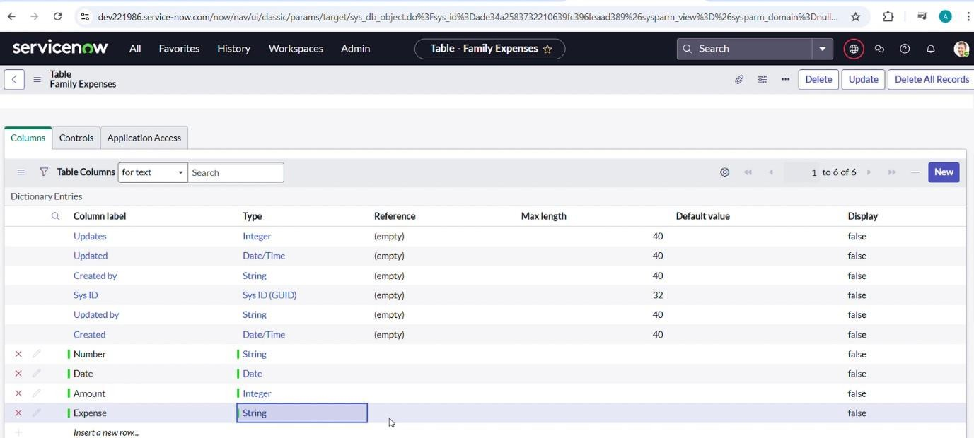

MILSTONE 3: CREATION OF TABLE FAMILY EXPENSES

Activity 3 – Making the Number Field an Auto-Number Open the Family Expenses table.
- Locate the Number field/column and double-click to open its properties.
- Scroll down and switch to the Advanced view.
- In the Default Value section:
  - Check the box for Use Dynamic Default.
  - Set the Dynamic Default Value to Get Next Padded Number.
- Click Update to save the changes.

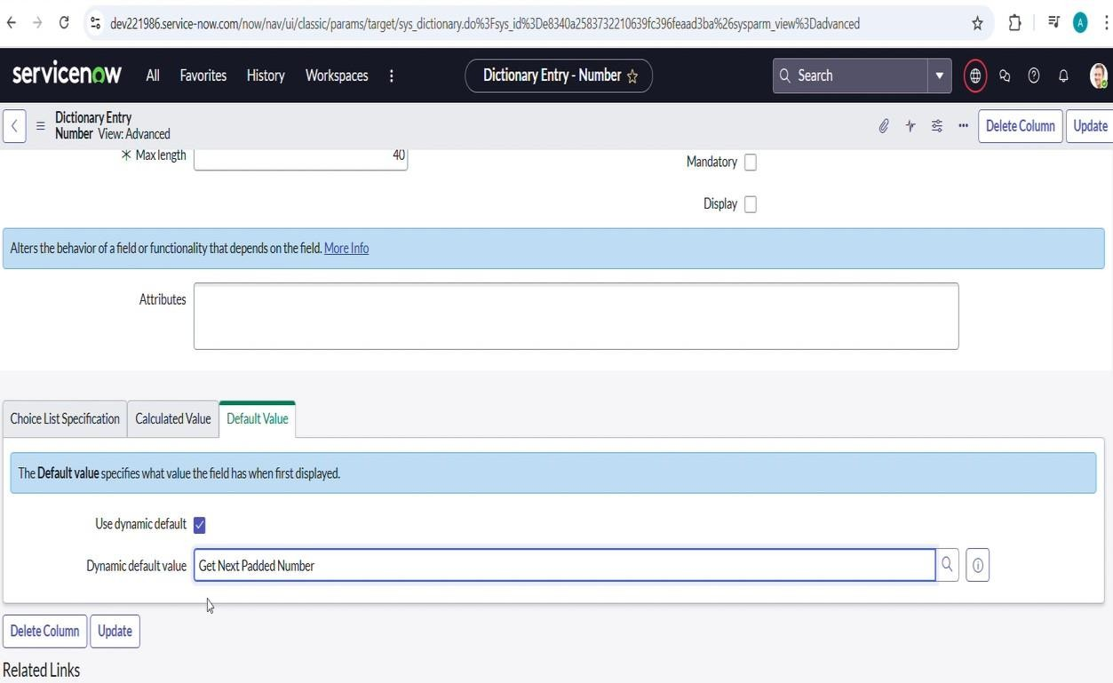

MILSTONE 3: CREATION OF TABLE FAMILY EXPENSES
Activity 4 – Configuring the Form
- Navigate to All > in the filter, search for Family Expenses.
- Open the Family Expenses table.
- Click on New to create a new form entry.
- On the form header, right-click and select:
  - Configure > Form Design.
- In the Form Designer, use drag-and-drop to:
  - Rearrange fields.
  - Group related fields together.
  - Add sections if required for better clarity.
- Save the customized form layout.

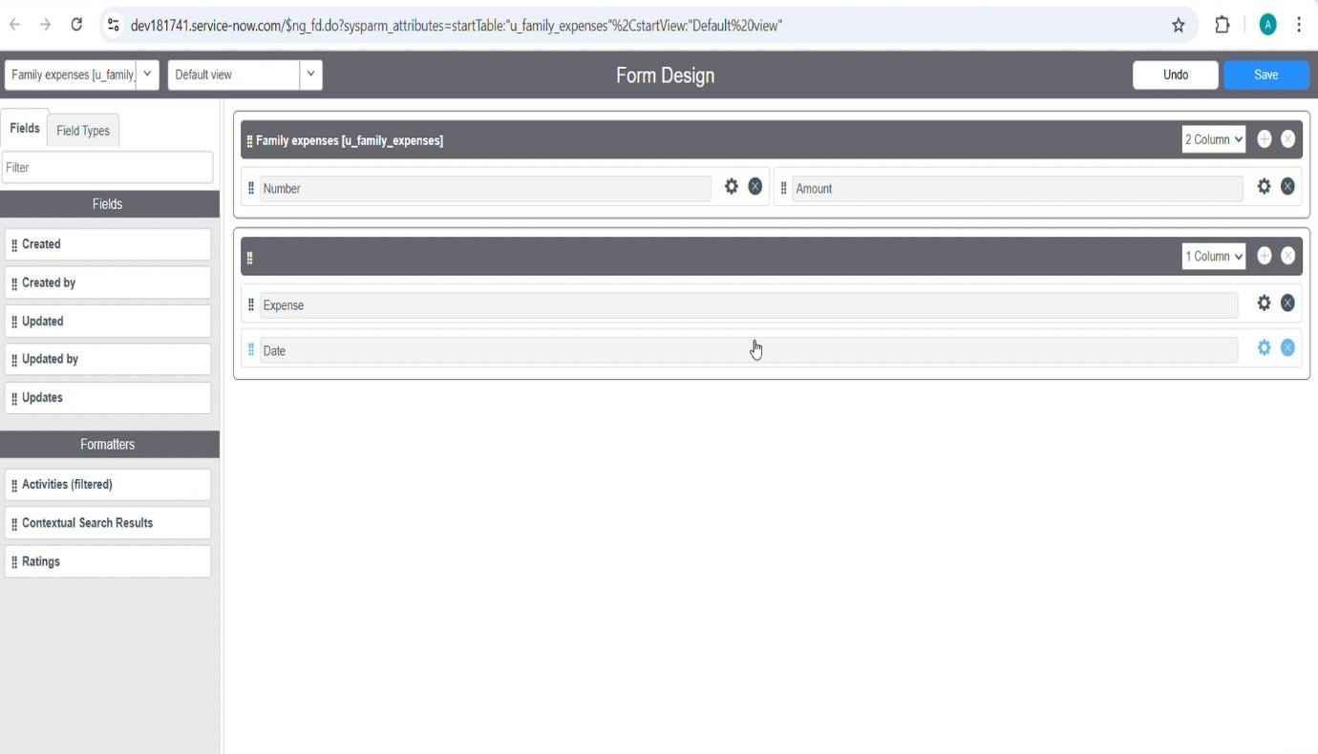

MILSTONE 4: CREATION OF TABLE DAILY EXPENSES

Activity 1 – Creating The Daily Expenses Table

- Navigate to All > Tables using the filter navigator.
- Click on New to create a new table.
- Fill in the required details:
- Label: Daily Expenses
- Name: (Auto-populated by the system)
- Add Module to Menu: Family Expenditure
- Go to the form header, right-click, and select Save.

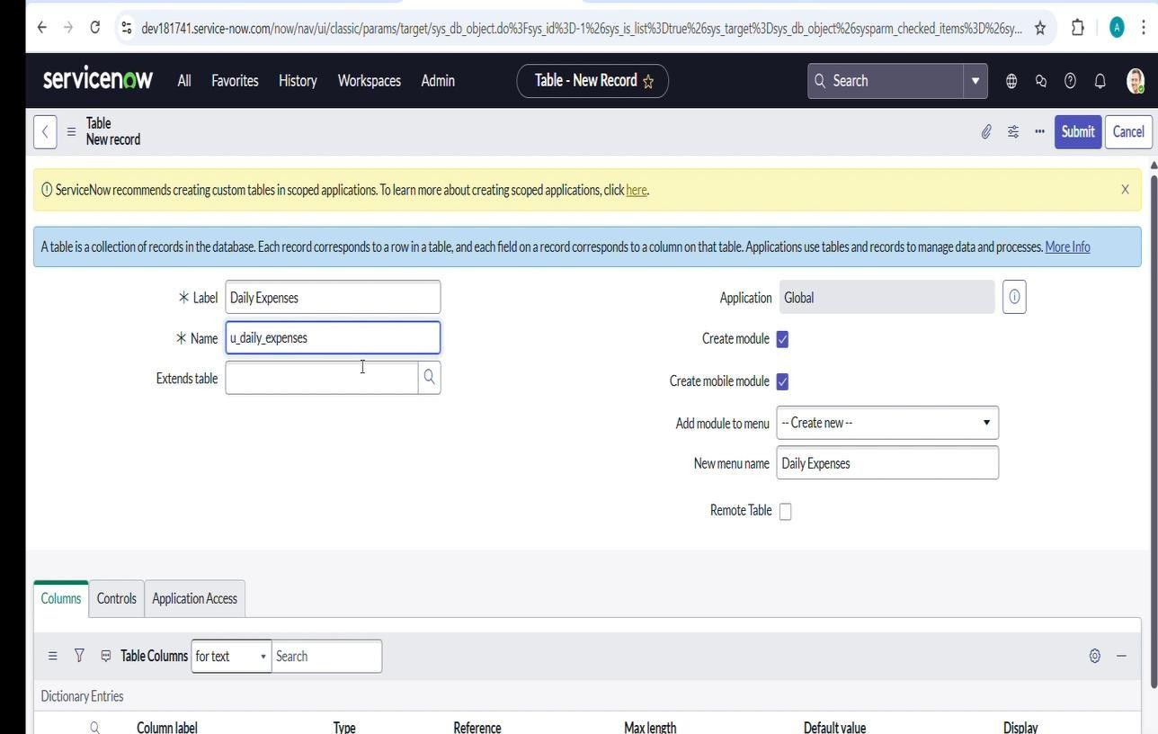

MILSTONE 4: CREATION OF TABLE DAILY EXPENSES

Activity 2 – Creating Columns (Fields)
- Open the Daily Expenses table.
- Near Columns, double-click to insert a new row and add the following fields:
- Column Label: Number
  - Type: String
- Column Label: Date
  - Type: Date
- Column Label: Expense
  - Type: Integer
- Column Label: Family Member Name
  - Type: Reference
  - Max Length: 800
- Column Label: Comments
  - Type: String
  - Max Length: 800

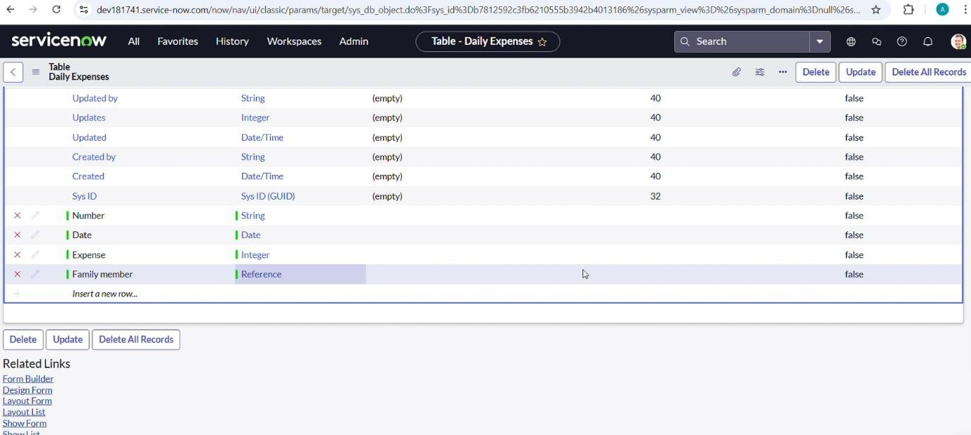

MILSTONE 4: CREATION OF TABLE DAILY EXPENSES

Activity 3 – Making Number Field an Auto-Number
- Open the Daily Expenses table.
- Locate the Number field/column and double-click to open its properties.
- Scroll down and switch to the Advanced View.
- In the Default Value section:
  - Check the box for Use Dynamic Default.
  - Set the Dynamic Default Value to Get Next Padded Number.
- Click Update to save changes. Configuring Number Maintenance:
- Navigate to All > Number Maintenance.
- Click on New.
- Enter the details as follows:
  - Table: Family Expenses
  - Prefix: MFE
- Click on Submit.

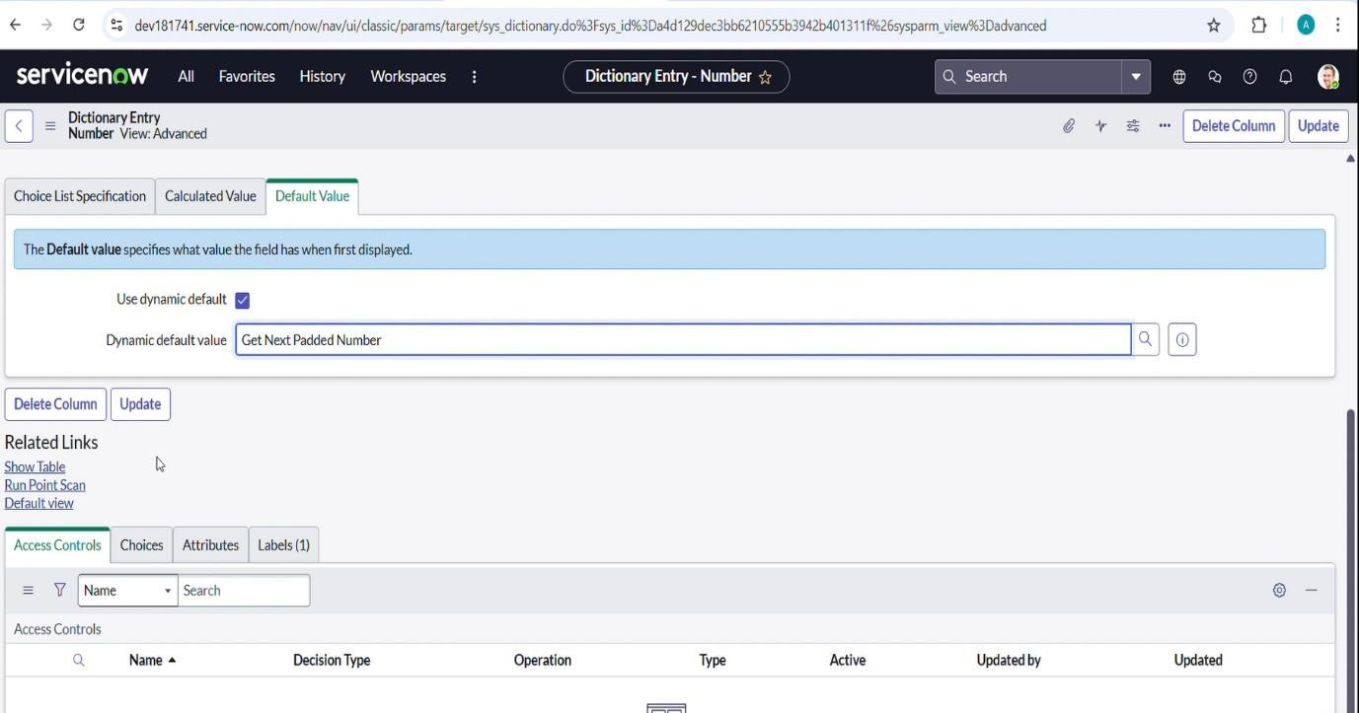

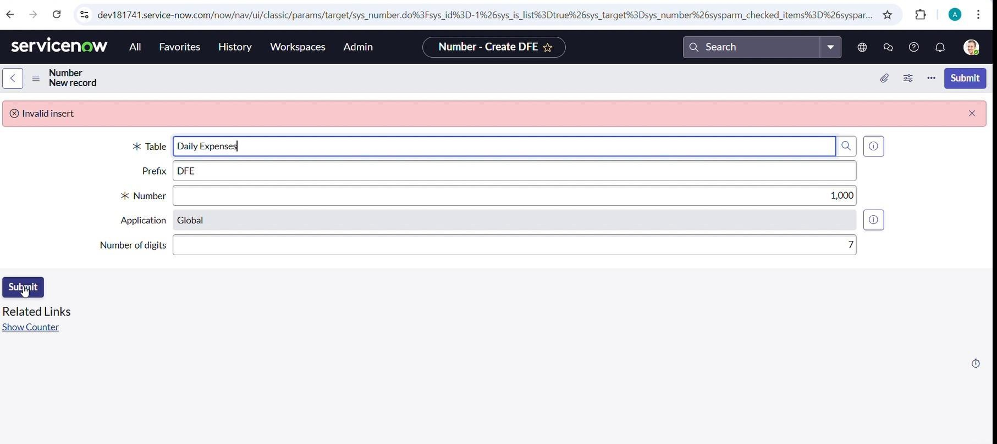

MILSTONE 4: CREATION OF TABLE DAILY EXPENSES

Activity 4 – Configure The Form
- Navigate to All > Daily Expenses using the filter.
- Open the Daily Expenses table.
- Click on New to create a new form entry.
- On the form header, right-click, then select:
- Configure > Form Design.
- In the Form Designer, drag and drop fields to customize the form layout as per requirement.
- Apply the following configurations:
- Number Field → Set as Read-Only by clicking the gear icon and checking Read-Only.
- Date Field → Set as Mandatory by clicking the gear icon and checking Mandatory.
- Family Member Name Field → Set as Mandatory using the same method.
- Click Save to apply the changes.
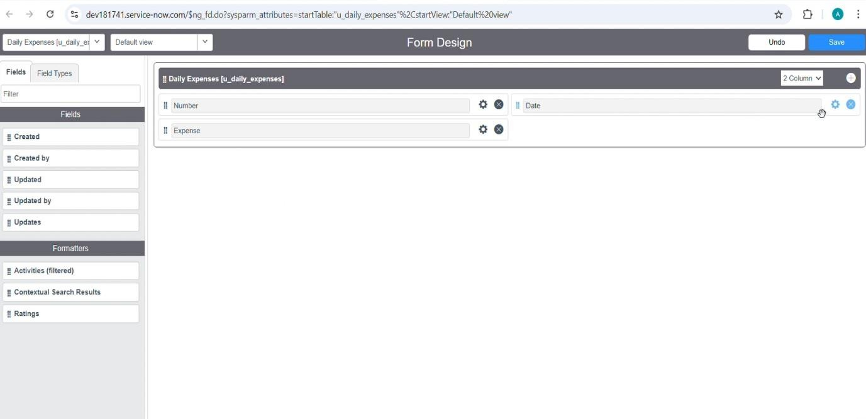

MILSTONE 5: CREATION OF RELATIONSHIP BETWEEN FAMILY EXPENSES AND DAILY EXPENSES TABLES

- Navigate to All > Relationships using the filter navigator.
- Click on New to create a new relationship.
- Fill in the details as follows:
- Name: Daily Expenses
- Applies to Table: Family Expenses
- Related List Table: Daily Expenses
- Click Save.

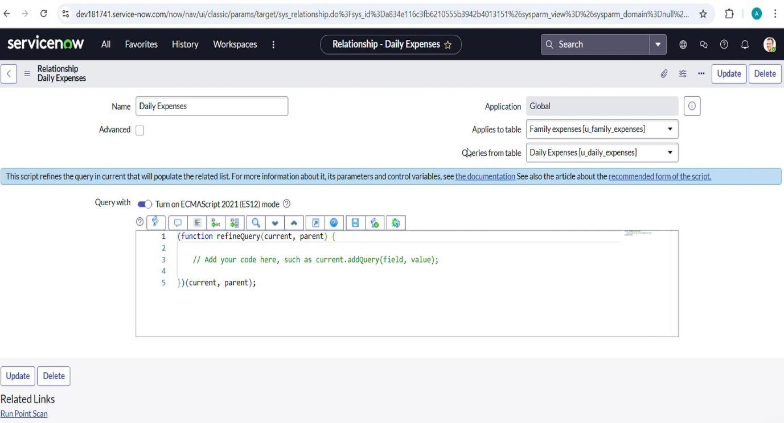

MILSTONE 6: CONFIGURING RELATED LIST ON FAMILY EXPENSES
- Navigate to All > Family Expenses using the filter.
- Open the Family Expenses table.
- Click on New to open the form view.
- On the form header, right-click, then select:
- Configure > Related Lists.
- From the available options, add Daily Expenses to the Selected Area.
- Click Save to apply the changes.

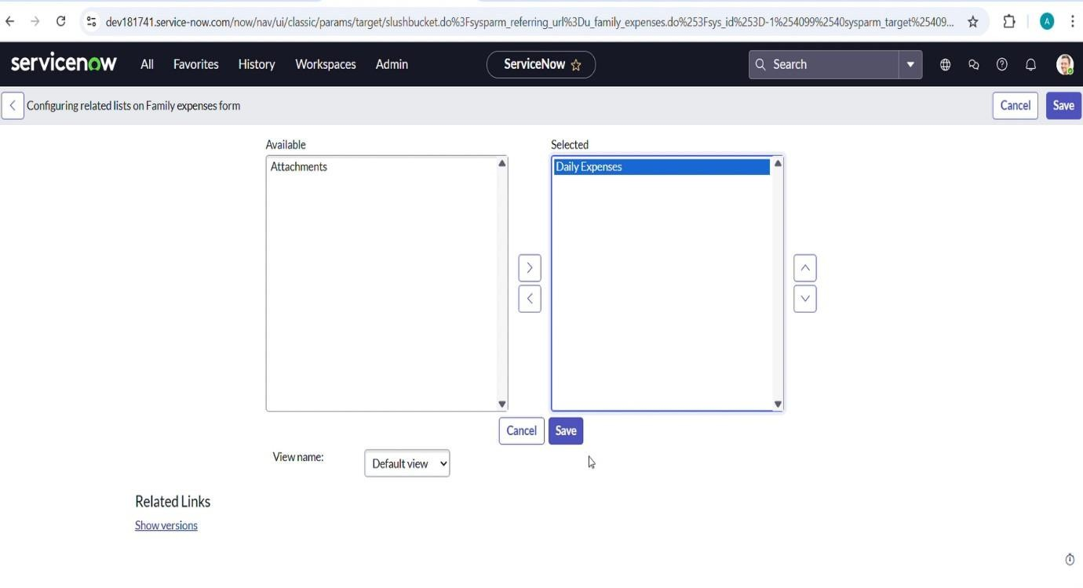

MILSTONE 7: CREATION OF BUSINESS RULES
- Navigate to All > Business Rules using the filter.
- Under System Definition, select Business Rules and click New.
- Enter the following details:
  - Name: Family Expenses BR
  - Table: Daily Expenses
  - Check Advanced.
- In the When to run section, check:
  - Insert
  - Update
- In the Advanced tab, add the following script:
(function executeRule(current, previous /*null when async*/) {

varFamilyExpenses = new GlideRecord('u_family_expenses'); FamilyExpenses.addQuery('u_date', current.u_date); FamilyExpenses.query();

if (FamilyExpenses.next()) { FamilyExpenses.u_amount += current.u_expense;
FamilyExpenses.u_expense_details += ">" + current.u_comments + ":" + "Rs." + current.u_expense + "/-";
FamilyExpenses.update();
} else {
var NewFamilyExpenses = new GlideRecord('u_family_expenses'); NewFamilyExpenses.u_date = current.u_date; NewFamilyExpenses.u_amount = current.u_expense; NewFamilyExpenses.u_expense_details += ">" +
current.u_comments + ":" + "Rs." + current.u_expense + "/-";

NewFamilyExpenses.insert();
}
})(current, previous);
Go to the form header, right-click, then select Save.

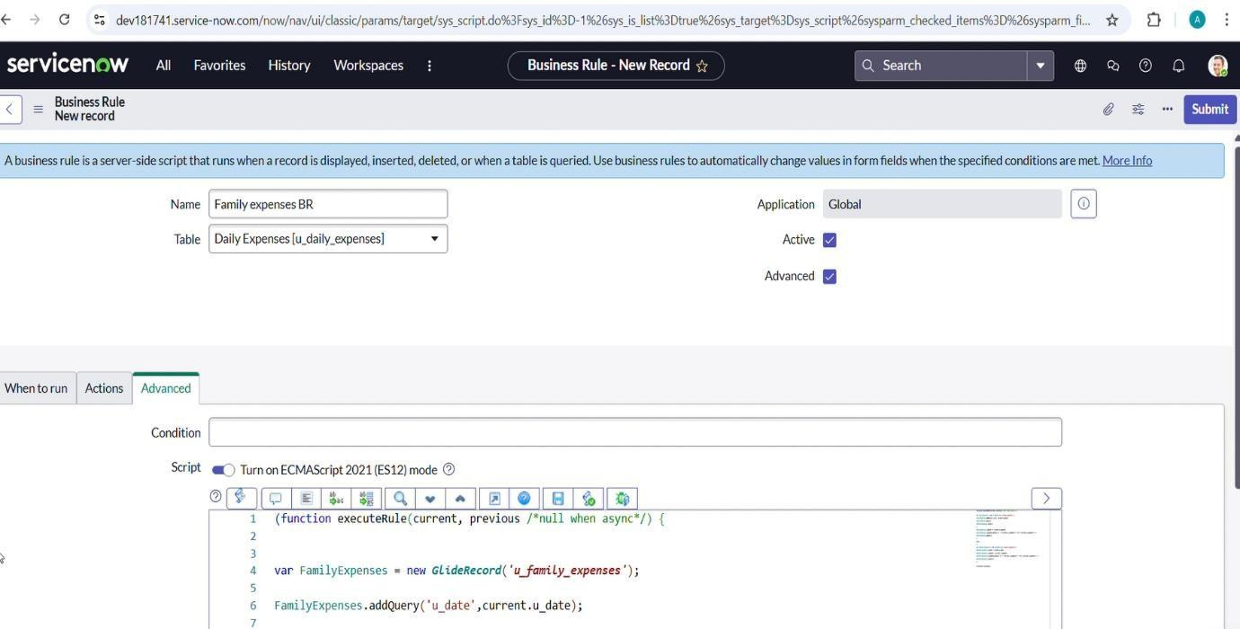

MILSTONE 8: CONFIGURE THE RELATIONSHIP

- Navigate to All > Relationships using the filter navigator.
- Open the existing Daily Expenses Relationship.
- Update the details as follows:
  - Applies to Table: Family Expenses
- In the Query with section, enter the following script: (function refineQuery(current, parent) {

// Add your code here, such as current.addQuery(field, value); current.addQuery('u_date', parent.u_date);
current.query();
})(current, parent);
Click Update to save the configuration
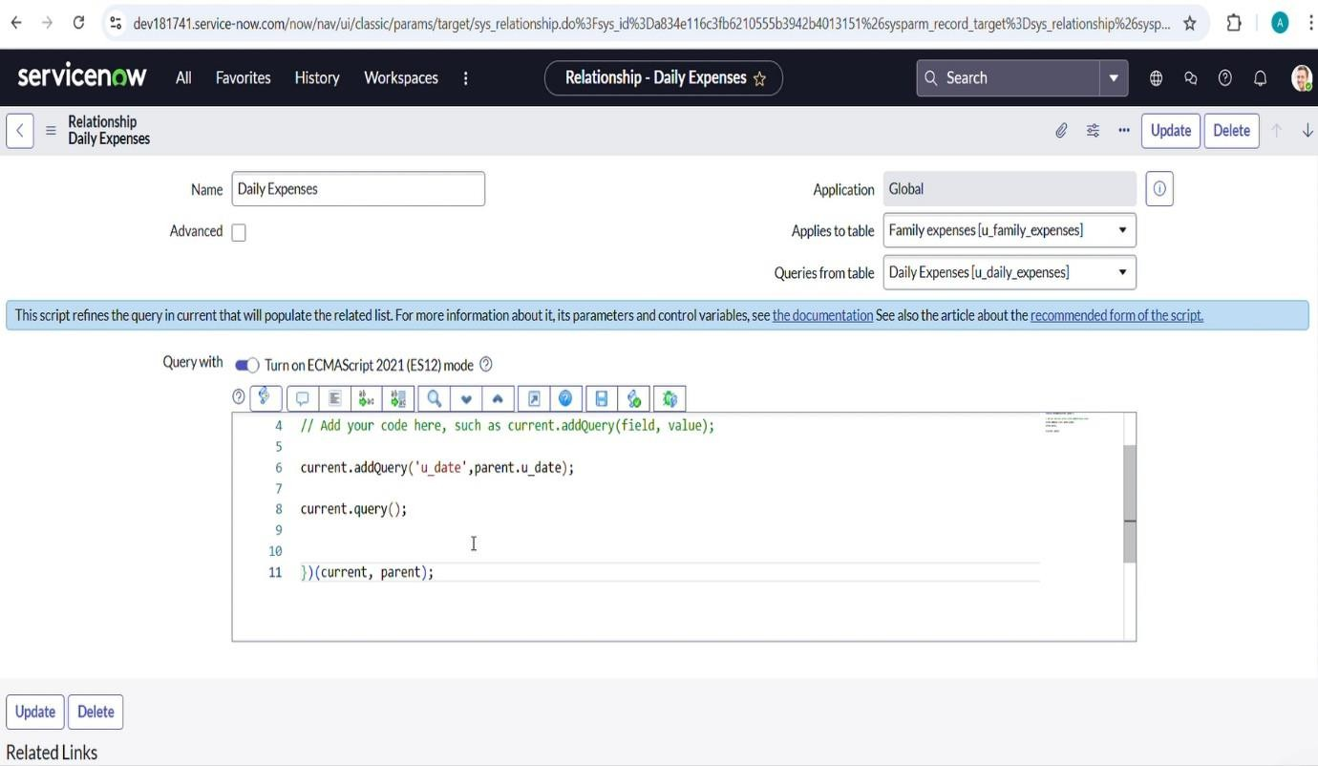

CONCLUTION

The Family Expenses Management System built on ServiceNow demonstrates how the platform can be leveraged beyond IT workflows to solve real-world problems. By systematically creating tables, relationships, forms, and business rules, the project enables seamless tracking of both daily expenses and family-level expenses in an automated manner.
The use of auto-numbering, mandatory fields, related lists, and business rules ensures data integrity, consistency, and accuracy. The relationship configuration further enhances visibility by linking daily records to family-level summaries, providing a clear financial overview.
Through this project, we learned how to apply ServiceNow features such as table creation, form design, field configuration, scripting, and automation to build a complete application. More importantly, it highlights how low-code/no-code platforms like ServiceNow can be extended into personal finance, household management, and non-IT use cases.
Overall, the project provides a practical, scalable, and user-friendly solution for managing family expenses efficiently while also strengthening skills in ServiceNow application development.

